Traveling Salesperson Problem (TSP) Solver using Simulated Annealing
MEMBERS:
SCS3/146871/2023 MWANZIA DANIEL
SCS3/2284/2023 CHWANYA JILTON BRIAN
SCS3/147171/2023 JACKTON OTIENO
SCS3/147342/2023 NGUGI SAMUEL
SCS3/2607/2022 MARXEEN NYAMBURA
1.0 Introduction
This report documents the implementation of a Simulated Annealing (SA) algorithm to solve the Traveling Salesperson Problem (TSP). The TSP seeks the shortest possible route that visits a set of cities exactly once and returns to the starting point. This project applies a stochastic optimization technique to find a near-optimal solution for a 20-city problem.
2.0 Methodology & System Design
2.1 Algorithm Selection
Simulated Annealing, a probabilistic metaheuristic, was chosen for its ability to escape local minima by occasionally accepting worse solutions during the search, inspired by the annealing process in metallurgy.
2.2 Key Components and Functions
2.2.1 Class: City
- Stores (x, y) coordinates for a city.
- distance_to(city): Calculates the Euclidean distance to another city.
2.2.2 Class: Tour
- Represents a candidate route (a permutation of cities).
- generate_individual(all_cities): Creates a random initial tour.
- get_distance(): Calculates the total tour length if not already cached.
- copy(): Returns a deep copy of the tour object.
2.2.3 Function: acceptance_probability(energy, new_energy, temperature)
- Returns 1.0 if the new solution (new_energy) is better (lower distance).
- If worse, returns a probability exp((energy - new_energy) / temperature).
- Purpose: Implements the Metropolis criterion, allowing worse moves with a probability that decreases as the system cools.
2.2.4 Function: simulated_annealing(cities)
- Core Algorithm:
  - Initialization: Sets a high initial temp (10000) and cooling_rate (0.003). Creates a random initial tour.
  - Annealing Loop: Continues while temp > 1.
  - Neighbour Generation: Creates a new candidate tour by swapping two random cities in the current tour (tour_pos1 and tour_pos2).
  - Evaluation: Calculates the distance (energy) of both current and new tours.
  - Acceptance: Uses acceptance_probability() to decide whether to move to the new solution.
  - Update Best: Keeps track of the best solution found globally.
  - Cooling: Reduces temperature: temp *= (1 - cooling_rate).
- Output: Prints initial/final distances and the optimal traversal order.
2.2.5 Function: plot_cities_and_route(cities, best_tour)
- Creates a two-panel visualization using Matplotlib.
- Left Panel: Scatter plot of all city locations (red dots).
- Right Panel: Displays the optimal route (blue lines connecting cities). The start city is highlighted in blue. The total distance is displayed in a text box.
3.0 Results and Discussion
3.1 Output Summary
For the provided 20-city dataset:
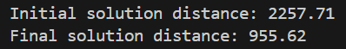
- Optimization achieved: A ~57.67% reduction in total travel distance.
3.2 Performance Analysis
- Effectiveness: Simulated Annealing successfully found a significantly shorter route than the random initial solution, demonstrating its capability for combinatorial optimization.
- Solution Quality: While not guaranteed to be the absolute global optimum (TSP is NP-Hard), the solution is visually coherent and represents a high-quality, practical route.
- Algorithm Behaviour:
  - The high initial temperature allowed extensive exploration of the solution space, accepting many worse moves.
  - As temperature cooled, the algorithm increasingly exploited good solutions, converging toward a stable, low-energy state.
  - The simple neighbour operation (city swap) was effective for this problem size.
- Visualization: The plots effectively contrast the random initial city distribution with the logical, connected final route. The clear highlighting of the start city and display of the total distance aids interpretation.
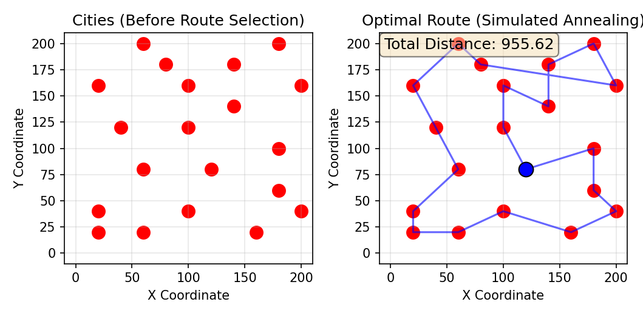
3.3 Limitations and Observations
- Stochastic Nature: Different runs may yield slightly different final distances due to the random elements in neighbour generation and acceptance.
- Parameter Sensitivity: Performance depends on initial temperature and cooling rate settings. These were chosen empirically.
- Scalability: For much larger city sets (e.g., >1000), the algorithm would require optimization of distance calculations and possibly more sophisticated neighbor operators.
4.0 Conclusion
The project successfully implemented a Simulated Annealing solver for the TSP. The object-oriented design with City and Tour classes provided clear data representation. The algorithm demonstrated robust performance, finding a high-quality solution that reduced the tour distance by over 50%. The visualization component effectively communicates the results. This implementation serves as a practical demonstration of how metaheuristics can tackle complex optimization problems where exact solutions are computationally infeasible.
5.0 References
- Kirkpatrick, S., Gelatt, C. D., & Vecchi, M. P. (1983). Optimization by Simulated Annealing. Science, 220(4598), 671–680.
- Černý, V. (1985). Thermodynamical approach to the traveling salesman problem: An efficient simulation algorithm. Journal of Optimization Theory and Applications, 45(1), 41–51.
- Garey, M. R., & Johnson, D. S. (1979). Computers and Intractability: A Guide to the Theory of NP-Completeness. W. H. Freeman and Company. (For the formal classification of TSP).
- Metropolis, N., Rosenbluth, A. W., Rosenbluth, M. N., Teller, A. H., & Teller, E. (1953). Equation of State Calculations by Fast Computing Machines. The Journal of Chemical Physics, 21(6), 1087–1092. (Original Metropolis algorithm)
- http://www.theprojectspot.com/tutorial-post/simulatedannealing-algorithm-for-beginners/6

